1U 4PON ，8PON OLT firmware update guide
This manual mainly shows that 1U 4PON, 8PON OLT software upgrade method, upgrade the OLT application need to use the TFTP server.
Pripojte si PC-NTB k portu GE1, AUX a nebo pomoci serial. kabelu k portu CONSOLE.
Otevrete telnet či ser. consoli /např putty/ a prihlaste se k OLT (default je 192.168.1.100 admin/admin)
nastavte si IP v OLT na vasi sit a nebo si nastavte IP vaseho PC/NTB ve stejném rozsahu jako je OLT:
system ipconfig inband 192.168.168.119 255.255.255.0
system ipconfig gateway 192.168.168.1
pust te TFTP server na PC/NTB a nastavte sparvny adresar s FW - viz níže
dejte upgrade na OLT:
system update firmware FD1104B_V2.4.02_170421_X000.img tftp-server 192.168.168.241 (adresa vaseho PC/NTB s TFTP serverem)
update WEB managementu :
system update web-server WEB_V1.0.0_170421_1831.img tftp-server 192.168.168.241

nechte probehnout automaticky upgrade a a je to ---viz obrázek obrazovky níže
1．Configure the TFTP server。
1）Open the TFTP server。
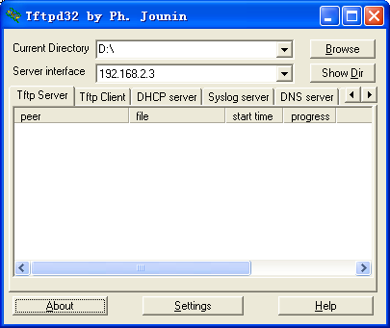
2）Click on the Settings option, will choose to check the following
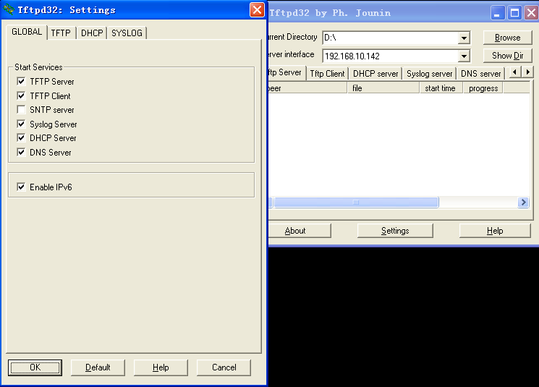
3）Click Browse, select upgrade file storage root directory
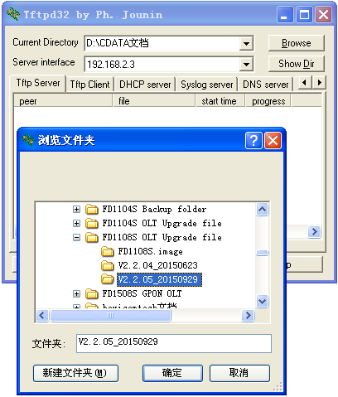
4）Click server interface options drop-down box, select the TFTP server's IP address （IP address should be chosen here and OLT management IP address of the same network segment）
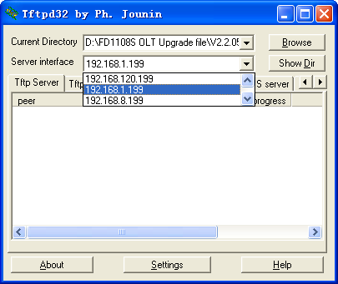
2．Firmware upgrade OLT
1）Use serial port connection OLT console port, login to the OLT command line interface, or use the network cable to connect the OLT AUX port, through the way of telnet login to the OLT command line interface.
To upgrade the command is：
epon#sys update firmware FD1108S_V2.2.05_150929_X000.img tftp-server 192.168.1.199（explain: the IP address here refers to the IP address of the TFTP server）
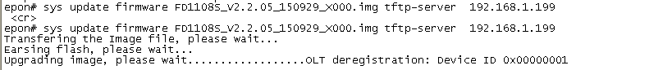
2）Wait for the system automatically upgrade steps, and then restart the OLT, system upgrade is completed, the following figure
